

**Instructions to implement Tapit Ads library in Basic4Android**

Tapit latest SDK implements a new type of ad called AdAlert. See screenshots below.

Step 1)

Register at <http://tapit.com/>, once you are registered create and add new application and choose the type of ad you will be using. You will receive a Zone ID for each type of ad you create.

Step 2)

Download the latest Tapit SDK, Unzip it to a safe location anywhere on your Desktop.

Step 3)

Download the TapitAds_V1.7.jar and TapitAds_V1.7.xml files and copy this files along with the TapitAdView.jar file to your additional libraries folder in C:\Program Files (x86)\Anywhere Software\Basic4android\Additional Libraries.

Step 4)

On the right side of Basic4Android under the Libs tab select the TapitAds_V1.7 library.

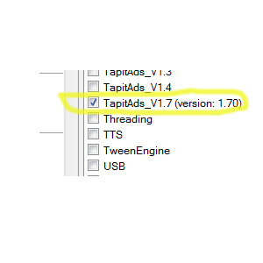

Step 5)

You are now ready and set up to start using Tapit Ads library, follow the example below for more information.

**Tapit Ads Basic4Android example.**

'Activity module

Sub Globals

'These global variables will be redeclared each time the activity is created.

'These variables can only be accessed from this module.

Dim tapit As TapitAd

Dim AdPrompt, interstitial, fullscreen, offerwall, videoview As Button

End Sub

Sub Activity_Create(FirstTime As Boolean)

'Do not forget to load the layout file created with the visual designer. For example:

Activity.LoadLayout("main")

AdPrompt.Initialize("AdPrompt")

interstitial.Initialize("interstitial")

fullscreen.Initialize("fullscreen")

offerwall.Initialize("offerwall")

videoview.Initialize("videoview")

tapit.Initialize("Banner", "8211") 'Initialize Banner ad and Enter Zone ID

Activity.AddView(tapit, 0, 0, 100%x, 100) 'Add Banner View to Activity to be displayed!

End Sub

Sub AdPrompt_Click

tapit.fireAlertAd("adprompt", "8214") 'Initialize AdPrompt and enter Zone Id

End Sub

Sub AdPrompt_adpromptready 'called when AdPrompt is ready to be displayed

Log("Ad Prompt is ready to be displayed")

tapit.showAdPrompt 'Show AdPrompt when ready!

End Sub

Sub interstitial_Click

Log("loading interstitial Ad")

tapit.interstitial("inter", "8212") 'Initialize Interstitial Ad and enter Zone Id

End Sub

Sub inter_ready 'Called when Interstitial is ready to be displayed

Log("ad has been loaded")

tapit.showInterstitial 'display interstitial ad when ready!

End Sub

Sub videoview_Click

tapit.videoview("video", "8212") 'Initialize VideoView and enter Zone ID

End Sub

Sub video_ready 'Called when videoview is ready to be displayed

tapit.showVideoAd 'Display videoAd when ready!

End Sub

Sub fullscreen_Click

tapit.adfullscreen("adfull", "8214") 'Initialize FullScreenAd and enter Zone ID

End Sub

Sub adfull_ready 'Called when FullScreenad is ready to be displayed

Log("Full screen Loaded and ready")

tapit.showFullScreen 'Display FullScreenAd when ready!

End Sub

Sub Banner_adloaded

Log("Ad Banner has been loaded")

End Sub

Sub offerwall_Click

tapit.offerwall("walloffer", "8214") 'Initialize Offerwall and Enter Zone ID

End Sub

Sub walloffer_ready 'Called when OfferWall is ready to be displayed

Log("wall offer is ready to load")

tapit.showOfferWall 'Display OfferWall when ready!

End Sub

Sub video_failed(error As String) 'Subs called when an error has occured!

Log("video Ad failed to show" & " " & error)

End Sub

Sub adfull_failed(error As String) 'Subs called when an error has occured!

Log("Full screen ad failed to load" & " " & error)

End Sub

Sub walloffer_failed(error As String) 'Subs called when an error has occured!

Log("walloffer failed to load" & " " & error)

End Sub

Sub Banner_failed(error As String) 'Subs called when an error has occured!

Log("Banner Ad has failed to load" & " " & error)

End Sub

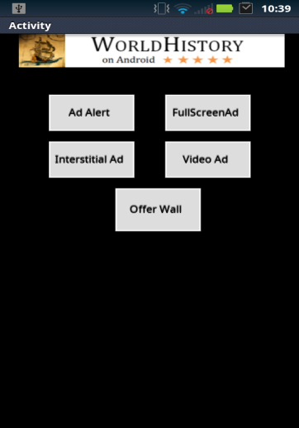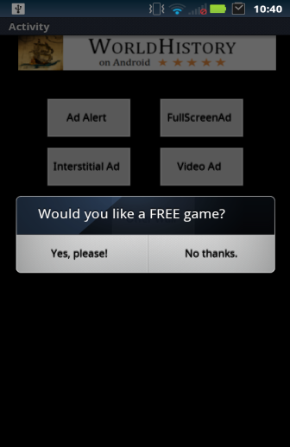  

Banner Ad Ad Alert Full Screen Interstitial

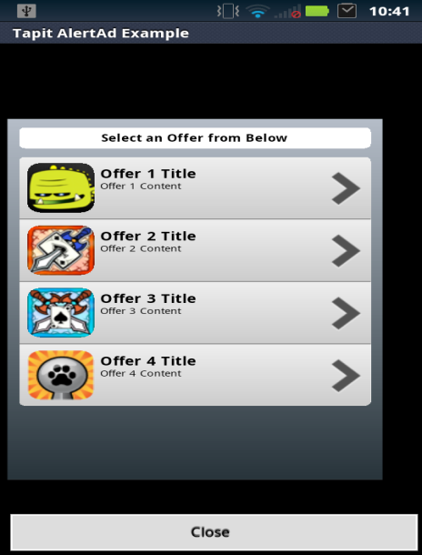

Offer Wall Ads